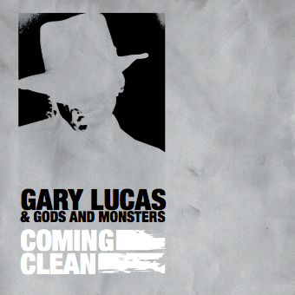
TRACKLIST :
1. Hurly Burly 9. Ain't Got You
2. Coming Clean 10. One Man's Meat
3. Ultra Shark 11. Spirit Moves
4. Evangeline 12. Under My Wing
5. Fata Morgana 13. Follow
6. Dream Of The Wild Horses
7. Psycho 14. Rosemary's Baby (bonus track)
8. Skin Diving 15. Grace (bonus track)

Label : DAWA RECORDS
Artiest : Gary Lucas & Gods and Monsters
Album : Coming Clean
Catalogusnummer : DW-CD 010
Marketing & Distributie : Suburban

Guitarist extraordinaire / Grammy-nominated songwriter GARY LUCAS (Captain Beefheart, Jeff Buckley) delivers the goods with "COMING CLEAN"-- a new studio album featuring his long-time psychedelic rock band GODS AND MONSTERS --and it's a killer, tying together all the diverse musical threads and then some of the man The Guardian calls "the legendary left-field guitarist". 'COMING CLEAN" showcases Gary at the top of his game, featuring his New Wave super group GODS AND MONSTERS (Billy Ficca from Television and Jonathan Kane from Swans on drums, Ernie Brooks from the Modern Lovers on bass), plus special guests David Johansen (New York Dolls), Ellis Hooks and sultry French superstar Elli Medeiros along for the trip. From the title track (mixed by Talking Head JERRY HARRISON) to the wild blues-rock showstopper "One Man's Meat", it's a total joy and a total knockout, and includes covers of everything from Hitchcock's "Psycho" theme to Springsteen's "Ain't Got You". Lucas plays the guitar like nobody else AND writes original, haunting songs (he-co wrote Jeff Buckley's "Grace" and "Mojo Pin" and Joan Osborne's "Spider Web")-- a rare talent indeed, and here at his most accessible-- a classic album from one of the most creative minds in modern rock.
www.garylucas.com www.myspace.com/garylucas

DAWA RECORDS is een opwindend nieuw indie label met bands die een voorliefde hebben voor avontuurlijke rock muziek met een uitgesproken smoel. Het label huisvest zowel nieuwe spannende acts als artiesten die al vele wapenfeiten op hun naam hebben staan. Het maken van spraakmakende, intense platen buiten de mainstream bundelt de krachten van deze bands op dit bijzondere label.

www.dawarecords.com www.myspace.com/dawarecords

Voor meer informatie kunt u contact opnemen met :

DAWA RECORDS B-COZ Entertainment Promotie
P.O. BOX 59621 P.O. BOX 59204
1040 LC AMSTERDAM 1040 KE AMSTERDAM
tel : 020-6839079 tel : 020-6125170
info@dawarecords.com berry@b-coz.com

